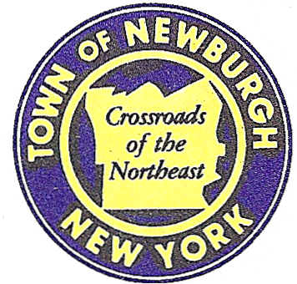

TOWN OF NEWBURGH
_______Crossroads of the Northeast __________________________
OLD TOWN HALL
308 GARDNERTOWN ROAD NEWBURGH, NEW YORK 12550

PLANNING BOARD
JOHN P. EWASUTYN, CHAIRMAN
TELEPHONE 845-564-7804
FAX 845-564-7802
E-MAIL: planningboard@townofnewburgh.org

PLANNING BOARD AGENDA

February 4th, 2016

*PLEASE NOTE: The Planning Board Meeting will start at 7:00 P.M. and all Applicants/Representatives
are to be present at that time. The Meeting will be held in the Meeting Room of Town Hall,
located at 1496 Route 300, Newburgh NY.*

1. CVS (2015-23) SITE PLAN
Corel Place (Route 52)
Section 60, Block 3, Lot 5.2
Zone: B
Rep: Cuddy & Feder LLP
300 Westage Business Center, Suite 380
Fishkill, NY 12524

2. Restaurant Depot (2015-33) SITE PLAN
NYS Route 300
Section 95, Block. 1, Lot 8
Zone: IB
Rep: Larry Marshall, P.E.
Mercurio Norton Tarolli & Marshall
45 Main Street
Pine Bush, NY 12566

3. Summit Lane (2015-18) SITE PLAN
Stewart Avenue
Section 97, Block 1, Lots 47 & 48
Zone: R-3
- Rep: JMC Planning Engineering Landscape
120 Bedford Road
Armonk, NY 10504

4. Golden Vista (99-33) ARB
2103 Route 300
Section 3-Block 1- Lot 82
Zone: AR
Rep: Maser Consulting, P.C.
555 Hudson Valley Avenue, Suite 101
Newburgh, NY 12550

5. Bell (16-01) 2 LOT SUBDIVSION
65 Lockwood Lane INITIAL APPEARANCE
Section 8, Block 1, Lot 4.22
Zone: AR
Rep: Sparaco & Youngblood ,PLLC
P.O. Box 818
18 N. Main St.
Harriman, NY 10926

6. Mann Subdivsion (16-02) 4 LOT SUBDIVSION
545 Lakeside Road INITIAL APPEARANCE
Section 28, Block 1, Lot 12.1
Zone: R1
Rep: Maser Consulting, P.C.
555 Hudson Valley Avenue, Suite 101
Newburgh, NY 12550

7. Fidanza (11-24) ARB-SIGNAGE
56 North Plank Road
Section 80, Block 7, Lot 7
Zone: B
Rep: Coppola Associates
6 Old North Plank Rd., Suite 101
Newburgh, NY 12550

PLANNING BOARD BUSINESS
WORK SESSION

February 4, 2016
5:30 P.M.

1. Gardner Ridge (02-29) Gross Density

